Smart Parking Platform

1.Existing Software Landscape
- ParkMobile – used for on-street payment in partnership with cities but focuses on payment processing rather than occupancy analytics or structured garage reservations.
- Passport – municipal parking platform used by cities for curbside and city-managed parking. It is good when it comes to enforcement and compliance but is more of a broad municipal solution than a platform tailored for real-time garage availability and garage reservations.
- SpotHero – large parking marketplace that connects drivers with parking locations across many cities. It is designed around helping users find and book parking for individual trips instead of supporting long-term integration with a city’s parking operations.
- ParqEx – smaller parking platform focused on garage access, billing, and reservations. Works well at the facility level but it does not appear to offer the same level of citywide occupancy analytics or ordinance-based pricing that a transportation department may need.
Differentiation: Existing platforms tend to prioritize individual garage access and reservations, municipal payment services, or large-scale parking marketplaces. What SmartPark brings to the table is being designed specifically for one city’s downtown garage network. That allows the system to prioritize city-specific requirements and integration with existing municipal payment infrastructure instead of trying to serve many different markets at once.

2.Vision and Scope
The SmartPark is a web and mobile system being developed for the City of Houston’s downtown parking garage network. The platform will allow drivers to find available parking, reserve spaces, and make payments in real time. Garage staff and transportation officials will also be able to monitor occupancy, manage statutory pricing and review utilization and accessibility data. The system will be introduced across Houston’s existing downtown garages with reservation and payment features prioritized first and reporting analytics added in later stages.

3.Software Requirements Specification
Users: Drivers, city garage staff and administrators, city transportation officials, finance departments, system administrators and third-party payment providers.
System Environment: The platform will include a web application and mobile applications for iOS and Android, supported by a cloud-hosted backend. It will integrate with the city’s existing payment infrastructure, garage occupancy systems and navigation services.
Constraints: The system must follow local laws and regulations, privacy, security and accessibility requirements. Parking prices must support resident discounts and event-based pricing. The project must be completed within the fixed timeline and integrate with the city’s existing payment infrastructure instead of replacing it.
Assumptions: Drivers are assumed to have access to a smartphone or web browser, and the city will provide current pricing and ordinance information needed by the system. Participating garages will have staff capable of manually updating parking availability or internet-connected occupancy sensors.

Functional Requirements
- FR1: The system shall display live open and occupied parking spots on a map.
- FR2: The system shall process digital payments via credit cards and mobile wallets.
- FR3: The system shall guide drivers to their assigned parking spot using GPS
- FR4: The system shall provide garage staff with a dashboard displaying parking occupancy.
- FR5: The system shall allow users to view previous reservations and access digital receipts.
- FR6: The system shall notify users when a reservation is confirmed and when their parking time is close to expiring.
- FR7: The system shall allow users to create an account and log in using email or supported single sign-on options
- FR8: The system shall allow drivers to reserve an available parking space up to 24 hours ahead while preventing the same space from being double-booked.
- FR9: The system shall support different permission levels for admins, managers, and regular team members
- FR10: The platform automatically detects and allows manual check-in via QR codes, or License Plate Recognition (LPR).

Non-Functional Requirements
- NFR1: The system shall handle payment information in compliance with applicable PCI-DSS requirements.
- NFR2: The system shall support at least 5,000 users at the same time.
- NFR3: The system shall maintain at least 99.5% uptime.
- NFR4: New users must be able to navigate the main interface easily without formal training.
- NFR5: All user passwords and project data must be encrypted.

4. Work Breakdown Structure
SmartPark’s WBS is consistent with each subsystem tracing back to the Functional Requirements I defined earlier.
- Authentication & User Management
  - Login/Registration
    - Email sign-up and login
    - Single sign-on (SSO) integration
  - Account & Permissions
    - User profile management
    - Role-based permissions
- Parking Availability & Reservations
  - Real-time availability map
    - Live open and occupied spot display
    - ADA-accessible space filtering
  - Reservation system
- Payment & Billing
  - Payment processing
    - Credit card / mobile wallet integration
    - PCI-DSS compliant handling
  - Receipts & History
    - Digital receipt generation
    - Reservation history view
- Navigation & Check-In
  - GPS navigation
    - Turn guidance to assigned spot
  - Garage check-in
    - QR code check-in
    - License Plate Recognition (LPR) check-in
- Admin Dashboard & Reporting
  - Garage staff dashboard
    - Real-time occupancy monitoring
    - Pricing management
  - Reporting & analytics
    - Utilization reports
    - ADA-compliance reports
- Notifications
  - Reservation confirmation
  - Expiration alerts

Project Timeline
This timeline is the first draft and will be refined as new project management techniques are learned and applied to each WBS module as I progress through the course.
Phase | 1 | 2 | 3 | 4 | 5 | 6 | 7 | 8 | 9 | 10 | 11 | 12 | 13 | 14 | 15
Research & Requirements
Vision, Scope & SRS
WBS & Timeline
Authentication & User Management
Availability & Reservations
Payments & Billing
Navigation & Check-In
Admin Dashboards & Reporting
Notifications
Integration & System Testing
UAT & Bug Fixes
Final Delivery & Presentation

Product Backlog and Sprint Planning
The product backlog for SmartPark was organized into four categories, tracked in Jira as Epics: Login, UI, Backend Processes, and Reporting. Each item was written as a user story or technical task following the standard Scrum backlog format.

Backlog: Login
ID | Item
L1 | As a driver, I want to create an account with my email and password, so that I can save my reservation history and payment info.
L2 | As a driver, I want to log in using single sign-on (Google/Apple), so that I don't have to remember another password.
L3 | As a garage staff member, I want to log in with role-based credentials, so that I only see tools relevant to my job.
L4 | As a system administrator, I want to reset a user's password on request, so that locked-out users can regain access.
L5 | As a user, I want to see a clear error message when login fails, so that I understand why I couldn't get in.
L6 | As a returning user, I want my session to stay active for a set period, so that I don't have to log in every time I open the app.

Backlog: UI
ID | Item
U1 | As a driver, I want to see an interactive map showing nearby parking garages, so that I can quickly find available options.
U2 | As a driver, I want available spaces color-coded by status (available/limited/full), so that I can judge availability at a glance.
U3 | As a driver, I want to filter the map to show only ADA-accessible spaces, so that I can find a space that meets my needs.
U4 | As a driver, I want to select a garage and see space-level detail, so that I know exactly what I'm reserving.
U5 | As a driver, I want a simple checkout screen showing price and time window before confirming, so that I know what I'm paying for.
U6 | As a driver, I want to view my reservation history and receipts in one screen, so that I can track past parking activity.
U7 | As a driver, I want a 'current reservation' screen showing time remaining, so that I know when I need to return to my car.
U8 | As a driver, I want push notifications to appear clearly in-app, so that I don't miss expiration warnings.
U9 | As a garage staff member, I want a dashboard showing real-time occupancy for my facility, so that I can monitor usage at a glance.
U10 | As a garage staff member, I want to add, edit, or remove a garage listing, so that I can keep facility information accurate.
U11 | As a garage staff member, I want to adjust pricing for a specific garage, so that I can apply event-based or resident rates.
U12 | As a garage staff member, I want a visual layout of individual spaces within a garage, so that I can see which specific spots are occupied.
U13 | As a city transportation official, I want a citywide occupancy dashboard aggregating all garages, so that I can assess downtown parking trends.
U14 | As a garage staff member, I want to manually override a space's status (e.g., mark out of service), so that I can account for maintenance or closures.
U15 | As a system administrator, I want an admin panel to manage user roles and permissions, so that I can control who accesses which tools.
U16 | As a garage staff member, I want a simplified mobile-friendly view of the dashboard, so that I can check occupancy while walking the facility.

Backlog: Backend Processes
ID | Item
B1 | Implement user authentication service supporting email/password and SSO (Google/Apple).
B2 | Build real-time availability sync service that updates space status across all connected clients within 30 seconds.
B3 | Implement reservation engine with conflict-checking logic to prevent double-booking of the same space.
B4 | Build payment processing integration (credit card and mobile wallet) with PCI-DSS compliant handling.
B5 | Implement digital receipt generation and storage tied to each completed transaction.
B6 | Build notification service to trigger confirmation and expiration alerts based on reservation time windows
B7 | Implement GPS/navigation API integration to generate turn-by-turn directions to a reserved space.
B8 | Build check-in verification service supporting both QR code scans and License Plate Recognition (LPR) input.
B9 | Build occupancy data ingestion service to pull real-time sensor data (or manual staff updates) per garage.
B10 | Implement garage management service supporting add/edit/remove operations on facility records.
B11 | Build dynamic pricing engine supporting event-based and resident-discount rate rules.
B12 | Implement role-based access control (RBAC) service distinguishing driver, staff, official, and admin permission levels.
B13 | Build reporting/analytics engine aggregating utilization data across garages for the reporting dashboard.
B14 | Implement ADA-compliance tracking service logging accessible-space usage for city reporting requirements.
B15 | Build audit logging service recording manual overrides (e.g., staff marking a space out of service).
B16 | Implement data sync service between the city's existing payment infrastructure and the platform's transaction records.

Backlog: Reporting
ID | Item
R1 | As a driver, I want to view a summary of my total parking spend over time, so that I can track my own expenses.
R2 | As a driver, I want to export my reservation history as a PDF, so that I can submit it for expense reimbursement.
R3 | As a driver, I want to see how often I've used a specific garage, so that I can decide if a monthly pass would save me money.
R4 | As a driver, I want to receive a monthly summary notification of my parking activity, so that I stay aware of my usage patterns.
R5 | As a garage staff member, I want a daily utilization report showing peak and off-peak occupancy, so that I can plan staffing accordingly.
R6 | As a garage staff member, I want a revenue report broken down by garage and time period, so that I can track facility performance.
R7 | As a city transportation official, I want a citywide ADA-compliance report showing accessible-space usage, so that I can meet regulatory reporting requirements.
R8 | As a city transportation official, I want a congestion trend report aggregating occupancy across all downtown garages, so that I can assess the effectiveness of the program.
R9 | As a finance department member, I want a transaction reconciliation report matching payments to reservations, so that I can verify billing accuracy.
R10 | As a garage staff member, I want to export any report as a spreadsheet (CSV/Excel), so that I can share data with stakeholders outside the platform.
R11 | As a system administrator, I want a report showing failed login or payment attempts, so that I can monitor for potential security issues.

Product Backlog and Sprint Planning
Sprint Goal: A driver can create an account, log in, and see a basic garage availability screen. Sprint 1 was scoped around the minimum vertical slide needed before any other features could be built since every other backlog item depends on a user being authenticated first. The sprint includes:
- All 6 Login items
- 2 supporting UI items: the driver-facing interactive map and the operator occupancy dashboard
- 3 supporting backend items: the authentication service, the occupancy data ingestion service and the role-based access control service
Reservations, payments, receipts and reporting were deliberately excluded from Sprint 1 since none of them are usable until login and basic availability are working end-to-end.

Sprint 1 Board
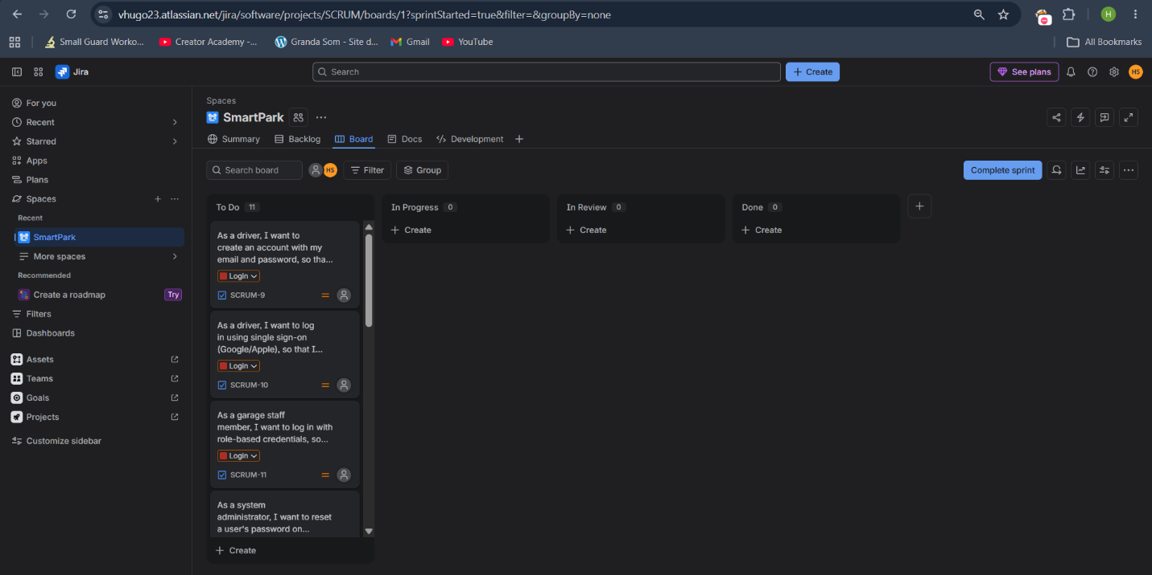
Figure 1: SmartPark Sprint 1 Board, Jira

